**DIGI CART ONLINE E-COMMERCE SHOPPING WEBSITE MANAGEMENT SYSTEM PROJECT**

ACKNOWLEDGEMENT

We take this occasion to thank God almighty for blessing us with his grace and taking our endeavour to a successful culmination. We extend our sincere and heartfelt thanks to our esteemed guide, **Mrs. MOUMITA SARKAR** for providing us with the right guidance and advice at the crucial junctures and for showing us the right way. We also take this opportunity to express a deep sense of gratitude to our respected Head of the Department **Mr. SOVONESH PAL** for their cordial support, valuable suggestions and guidance. We extend our sincere thanks to him for allowing us to use the facilities available. We would like to thank the other faculty members also on this occasion. Last but not the least, we would like to thank our friends / co-students for their support and encouragement they have given during the course of our work.

ABSTRACT

**Digi Cart** is a project which aims in developing a computerized system to make the purchase of electronics easy. This project has many features which are generally not available in normal online shopping management system like if a customer is generally not available on the exact date of product delivery it can set up a fix date according to its choice. This system allows to search number of stocks details of electronic items. Different types of electronic items will be available to the users in this application. The system will ease the shopping operations for customer of online store. It will provide administration functionality to manage categories and products. Customer will be able to browse and search products under different categories. Selected products or items for purchase would be added into the virtual shopping cart, which can be managed separately by customer. It can be examined at any time by customer for selected products, their quantity & price.

Overall, this project of ours is being developed to help the customers as well as admin of shopping website to maintain the shopping website in the best way possible and also reduce the human effort.

INDEX

**1. INTRODUCTION**

**2. SYSTEM ANALYSIS**

**2.1 SOFTWARE REQUIREMENT SPECIFICATIONS**

**2.2 EXISTING VS PROPOSED SYSTEMS**

**2.3 SYSTEM SPECIFICATIONS**

**3. DESIGN APPROACH**

**3.1 INTRODUCTION TO DESIGN**

**3.2 ER DIAGRAM**

**3.3 ACTIVITY DIAGRAM**

**3.4 DATA FLOW DIAGRAM**

**4. PROJECT MODULES**

**5. IMPLEMENTATION**

**5.1 CONCEPTS AND TECHNIQUES**

**5.2 TESTING**

**6. OUTPUT SCREENS**

**7. CODE SNIPPETS**

**8. CONCLUSION**

**9. FUTURE ENHANCEMENTS**

**10. BIBILIOGRAPHY**

INTRODUCTION

eCommerce (Electronic Commerce) is process of doing business through computer networks. The primary goal of Digi Cart website is to sell goods and services online. Online shopping is a form of electronic shopping store where the buyer is directly online to the seller’s computer usually via the internet. A person sitting on his chair in front of a computer can access all the facilities of the Internet to buy or sell the products. Digi Cart helps in buying of goods, products and services online by choosing the listed products from website (E-Commerce site). The Shopping cart is mainly useful for who haven’t time to go to shopping. Shopping cart is a very important feature used in Digi Cart to assist people making purchases online. The sale and purchase transaction are completed electronically and interactively in real-time. User can login into Digi Cart website.

 Once the customer logged in then automatically one shopping cart will be created, once user select an item it will add to cart. In case user thinks the selected item is not useful for him, then he can delete that item form the cart.

The proposed system helps in building a website to buy, sell products or goods online using internet connection. Unlike traditional commerce that is carried out physically with effort of a person to go and get products, Digi Cart has made it easier for human to reduce physical work and to save time. The basic concept of the application is to allow the customer to shop virtually using the Internet and allow customers to buy the items and articles of their desire from the store. Digi Cart is fast gaining ground as an accepted and used business paradigm.

More and more business houses are implementing web site providing functionality for performing commercial transactions over the web. Digi Cart provide consumers with less expensive products and services by allowing them to shop in many places and conduct quick comparisons. E-Commerce which was started in early 1990’s has taken a great leap in the world of computers, but the fact that has hindered the growth of e-commerce is security. Customer selected some items, but in his credit or debit cart haven’t that much balance, then he was logout from the website, the selected items are stored at cart with specific users with his allotted carts, after some days he bought those items then automatically deleted from the cart.  
  
  
Digi Cart System is the simple shopping solution. In day-to-day life, we will need to buy lots of goods or products from a shop. Customer can login and get various information about product and can purchase the suitable product. Customer can pay online, so security is must therefore eCommerce website provides secure transactions. Now a days, it is really hard to get some time to go out and get them by ourselves due to busy life style or lots of works. In order to solve this, Business to Customer E-Commerce websites have been started. Using these websites, we can buy goods or products online just by visiting the website and ordering the item online by making payments online.

After sale Digi Cart website also provide after sales service in which customer problem is solved.

**OBJECTIVE:**

The project aims and objectives that will be achieved after completion

of this project are discussed below. The aims and objectives are as follows: -

Digi Cart is mainly useful for who haven’t time to go to shopping,

those are just entered into this website and bought whatever they

want. Even it is night or morning they entered into the website.

Customer is our god, mainly this website is based on this formula.

After chosen items the customer bought into Pay pal process like VISA

or MASTER credit cards or any Debit cards are accepted in this

website. Customer is happily shopping at his rest place.

A customer will be able to do Online electronics shopping with all the electronics product availability in a drop-down format. A User will be able to access a search column to search a product an implementation of a Login system for user to order a product or add item in cart will be occurred. An Add to Cart system will be generated for the customer. A customer can access Live QR code generation for the procedure of payment system.

The main objective of the Online Shopping system is to manage the details of shopping, payment, bills and delivery on time to customer.

There will be an E-Mail process for problem solving and customer queries to resolve the problems.

and also, a Login System for admin to access the admin panel, and maintenance of the system so that a customer can access the system easily and enjoy their shopping.

**PROJECT OVERVIEW:**

Once customer entered with his own username and password, at that time automatically one shopping cart will be created, once user select an item it will add to cart. In case user thinks the selected item is not useful for me, then deleted that item from shopping cart.

Customer selected some items, but in his credit or debit cart haven’t that much balance, then he was logout from the website, the selected items are stored at cart with specific users with his allotted carts, after some days he bought those items then automatically deleted from the cart.

SYSTEM ANALYSIS

In this we are going to discuss and analyse about the developing process of Digi Cart E-Commerce Website including Software Requirement Specification (SRS) and comparison between existing and proposed system. The functional and non-functional requirements are included in SRS part to provide complete description and overview of system requirement before the developing process is carried out. Besides that, existing vs proposed provides a view of how the proposed system will be more efficient than the existing one.

**SYSTEM REQUIREMENT SPECIFICATION**

**GENERAL DESCRIPTION**

PRODUCT DESCRIPTION:

* E-commerce is the purchasing, selling & exchanging goods and services over computer network or internet through which transactions or terms of sale are performed electronically

* It consists of buying and selling goods and services over an electronic system such as the internet.
* It is commonly known as electronic marketing.

PROBLEM STATEMENT:

The problem occurred before having computerized system includes:

* Time Consuming -When computerized system is not implemented it takes too much time. And markets were not always opened, so it has some specific time slot to buy any product.
* No Assured Brand – When a computerized system is not there, there were often a chance no surety of assured branded materials for which often people get cheated also.
* When there was no computerized system, people had to find different places for a product.
* Cost consuming -As there is no computerized system there is always a travelling expense.

**SYSTEM OBJECTIVES**

* Improvement in control and performance -The system is developed to cope up with the current issues and problems of the commercial industry. The system can add customers and special members (business members) and is also bug free.
* Save cost -After computerized system is implemented less human force will be required to maintain the stocks thus reducing the overall cost.

* Save time -Owners will be able to search record by using few clicks of mouse and few search keywords thus saving his valuable time.

* Message -Through messaging system owners can send message to their customers and vice versa.
* Buying/selling 24/7.
* More reach to customers, there is no theoretical geographic limitations.
* Low operational costs and better quality of services. No need of physical company set-ups.
* Easy to start and manage a business.
* Customers can easily select products from different providers without moving around physically.

**NON-FUNCTIONAL REQUIREMENTS**

EFFICIENCY REQUIREMENT

When an E-Commerce system will be implemented owners and customers will easily access store as searched and items transaction will be very faster.

RELIABILITY REQUIREMENT

The system should accurately perform any type of user’s registration, member validation, item transaction and search.

USABILITY REQUIREMENT

The system is designed for a user-friendly environment so that customers and shop owners of any business easily understands the processes and can perform the various tasks easily and in an effective way.

CLIENT REQUIREMENT

* This system should work on OS Windows XP and above OS updates.
* Having both Cash on Delivery and secured online payment gateway mode.
* It should have Cart System where all the bill details and delivery date will be given.
* Customers can select their delivery dates if they want specific date delivery but have to pay more as per the ordered item, otherwise delivery of orders will take place within 6-7 days.
* Customers can give their order product reviews.
* Organization will be able to add and remove items if required.
* Organization will be able to see the necessary ordered item details like product name and id, price of product, weather its prepaid or COD, Customer’s address, email id and phone number.

IMPLEMENTATION REQUIREMENTS

In implementing whole system uses html in front end with php as server-side scripting language which will be used for database connectivity and the backend i.e., the database part is developed using MySQL.

DELIVERY REQUIREMENTS

The whole system is expected to be delivered in six months of time with a weekly evaluation by the project guide.

**FUNCTIONAL REQUIREMENTS**

1. MINIMUM SPECIFICATTIONS TO RUN
2. ADMINSTRATION TEAM USERS
3. NEW USER LOGIN
4. REGISTERED NORMAL USERS
5. PRODUCT ENROLLMENT
6. PRODUCT SEARCH BAR
7. ORDERED AND RETURNED PRODUCTS

HARDWARE AND SOFTWARE REQUIREMENT:

Description of feature

In this client has said about its minimum hardware & software requirement to run the website

Requirements

Hardware Requirement

* Intel Core 2 (Processor)
* 1 GB RAM
* 256 KB Cache Memory
* Hard disk 10 GB
* Microsoft Compatible 101 or more Key Board

Software Requirement

* Any User weather its admin or customer, they will be easily understanding without any proper training also how to use the system.

ADMINISTRATION TEAMUSERS:

Description of feature

In this admin user can handle the admin panel features and functions.

Requirements

-Admin team will be able to add and remove any sort of products which are available and not available respectively.

-Admin team will be able to see the client’s details if necessary.

-Admin team will be able to see what their customers has ordered from the website.

-If new admin users join, they will be able to join them in the admin panel.

-Admin Users will be able to answer the queries of customers.

-Admin members will be able to logout from their account and delete their account only if permission is granted by the Administration Team Manager.

NEW USER LOGIN:

Description of feature

This feature can be performed by all users to register as a new user to create account.

Requirements

-System must be able to verify information.

-System must be able to delete information if information is wrong.

REGISTERED NORMAL USERS:

Description of feature

This feature used by the user to login into system. They are required to enter user id and password before they are allowed to enter the system. The user id and password will be verified and if invalid id is their user is not allowed to enter the system.

Requirements

-user id is provided when they register.

-The system must only allow user with valid id and password to enter the system.

-The system performs authorization process which decides what user level can access to.

-The user must be able to logout after they finished using system.

PRODUCT ENROLLMENT:

Description of feature

This feature allows to add new items to the store

Requirements

-System must be able to add new items.

-System must be able to enter number of stocks of items into database.

- System must be able to not allow two items having same item id.

PRODUCT SEARCH BAR:

Description of feature

This feature is found in store maintenance part. we can search for items based on item name, item type or by brand name.

Requirements

- System must be able to search the database based on select search type

- System must be able to filter items based on keywords entered

- System must be able to show the filtered items in table view

ORDERED PRODUCTS AND RETURNED PRODUCTS:

Description of feature

This feature allows to buy and return items and also view reports of items ordered.

Requirements

-System must be able to enter order information in database.

-System must be able to update number of items in its stock.

- System must be able to search if items are available or not before its ordered.

-System should be able to enter order, delivery and return date information.

EVENT ADDITION:

Description of feature

This feature allows admin team to add information about various offers being given on any product as per date and time.

Requirements

-System should be able to add detailed information about events.

-System should be able to display information in the homepage of the website.

**EXISTING SYSTEM vs PROPOSED SYSTEM**

**EXISTING SYSTEM**

The present scenario for shopping is to visit the shops and market manually. And then from the available products list one needs to choose the item

He/she wants and then pay for the same item mainly in cash mode is done, as not every society is well educated and aware to use net banking or card modes or wallets etc.

DISADVANTAGES:

The following are the disadvantages of the existing system

* It is difficult to maintain important information in books.
* More manual hours need to generate required reports.
* It is tedious to manage historical data which needs much space to keep all the previous years’ ledgers, books etc.
* Daily sales and purchases details must be entered into books are very difficult to maintain.

**PROPOSED SYSTEM**

In the proposed system customers need not to go to the shops for purchasing the products he/she wishes to buy through the use of this system platform.

The system also endorses a home delivery system for delivering the purchased products.

The software application which avoids more manual hours that need to spend in record keeping and generating reports. This application keeps the data in a centralized way which is available to all the users simultaneously. It is very easy to manage historical data in database. No specific training is required for the distributors to use this application. They can easily use the tool that decreases manual hours spending for normal things and hence increases the performance. It is very easy to record the information of online sales and purchases in the databases.

**OBJECTIVE OF THE SYSTEM**

The objective of the Distributors Management Tool is to provide better information for the users of this system for better results for their maintenance in the product details that is sales, purchases and stock.

**SYSTEM SPECIFICATIONS**

Hardware Tools Used: -

· Pentium-IV(Processor).

· 256 MB Ram

· 512 KB Cache Memory

· Hard disk 10 GB

· Microsoft Compatible 101 or more Key Board

Software Tools Used: -

1. The front end is designed using of html, CSS.

* HTML- The full form of HTML is **Hypertext Markup Language.** HTML is a standard mark – up language that used build files that are showcased as a web page throughout the browsers. With CSS (Cascading Style Sheet) and JS (JavaScript) inside it, this language becomes more engaging and appealing. The term HTML describes a specific basic definition inside it. Hypertext arises from the hyperlink, which implies links between many pages and the markup suggests that the specified items would be the layout of the pages and the items inside it. The language incorporates both the functionality and making it the language of hypertext markups.

ADVANTAGES OF HTML

* HTML is the most straightforward language. This language is straightforward to understand, & simple to configure.
* The language is so versatile that you really can build whatever you want, including the text, a creative way to construct web pages together.
* It can render linkable text, as users could connect through these features from one page to other or website.
* Users can add images, pictures, gifs or sound whatever they want to make the site more appealing and understandable.
* CSS- Cascading Style Sheets (CSS) is a style sheet language used for describing the look and formatting of a document written in a markup language. While most often used to style web pages and interfaces written in HTML and XHTML, the language can be applied to any kind of XML document, including plain XML, SVG and XUL. CSS is a cornerstone specification of the web and almost all web pages use CSS style sheets to describe their presentation.CSS is designed primarily to enable the separation of document content from document presentation, including elements such as the layout, colours, and fonts. This separation can improve content accessibility, provide more flexibility and control in the specification of presentation characteristics, enable multiple pages to share formatting, and reduce complexity and repetition in the structural content (such as by allowing for table less web design).

ADVANTAGES OF CSS

* CSS saves time − You can write CSS once and then reuse the same sheet in multiple HTML pages. You can define a style for each HTML element and apply it to as many Web pages as you want.
* Easy maintenance − To make a global change, simply change the style, and all elements in all the web pages will be updated automatically.
* Global web standards − Now HTML attributes are being deprecated and it is being recommended to use CSS. So it's a good idea to start using CSS in all the HTML pages to make them compatible with future browsers.
* Platform Independence − The Script offer consistent platform independence and can support latest browsers as well.

1. The back end is designed using of java-script, PHP.

* PHP- PHP is a server-side scripting language designed for web development but also used as a general-purpose programming language. PHP is now installed on more than 244 million websites and 2.1 million web servers. While PHP originally stood for Personal Home Page, it now stands for PHP: Hypertext Pre-processor, a recursive backronym. PHP code is interpreted by a web server with a PHP processor module, which generates the resulting web page: PHP commands can be embedded directly into an HTML source document rather than calling an external file to process data. It has also evolved to include a command-line interface capability and can be used in standalone graphical applications. PHP is free software released under the PHP License. Most web servers and also as a standalone shell on almost every operating system and platform, free of charge.

ADVANTAGES OF PHP

* Most important advantage of PHP is that it’s open source and freed from cost. It is often downloaded anywhere and readily available to use for event of web applications.
* It is platform independent. PHP based applications can run on any OS like UNIX, Linux and windows, etc.
* Application can easily be loaded which are based on PHP and connected to database. it’s mainly used due to its faster rate of loading over slow internet and speed than another programming language.
* JavaScript is a dynamic computer programming language. It is lightweight and most commonly used as a part of web pages, whose implementations allow client-side script to interact with the user and make dynamic pages. It is an interpreted programming language with object-oriented capabilities. JavaScript was first known as Live Script, but Netscape changed its name to JavaScript, possibly because of the excitement being generated by Java. JavaScript made its first appearance in Netscape 2.0 in 1995 with the name Live Script. The general-purpose core of the language has been embedded in Netscape, Internet Explorer, and other web browsers.
* Client-side JavaScript is the most common form of the language. The script should be included in or referenced by an HTML document for the code to be interpreted by the browser.

## Advantages of JavaScript

* Less server interaction − You can validate user input before sending the page off to the server. This saves server traffic, which means less load on your server.
* Immediate feedback to the visitors − They don't have to wait for a page reload to see if they have forgotten to enter something.
* Increased interactivity − You can create interfaces that react when the user hovers over them with a mouse or activates them via the keyboard.
* Richer interfaces − You can use JavaScript to include such items as drag-and-drop components and sliders to give a Rich Interface to your site visitors.

1. DATABASE: MARIA DB

* MariaDB is a community-developed, commercially supported [fork](https://en.wikipedia.org/wiki/Fork_(software_development)) of the [MySQL](https://en.wikipedia.org/wiki/MySQL) [relational database management system](https://en.wikipedia.org/wiki/Relational_database_management_system) (RDBMS), intended to remain [free and open-source software](https://en.wikipedia.org/wiki/Free_and_open-source_software) under the [GNU General Public License](https://en.wikipedia.org/wiki/GNU_General_Public_License). Development is led by some of the original developers of MySQL, who forked it due to concerns over its [acquisition](https://en.wikipedia.org/wiki/Takeover) by [Oracle Corporation](https://en.wikipedia.org/wiki/Oracle_Corporation) in 2009.
* MariaDB intended to maintain high compatibility with MySQL, ensuring a drop-in replacement capability with library binary parity and exact matching with MySQL [APIs](https://en.wikipedia.org/wiki/Application_programming_interface) and commands. However, new features diverge more. It includes new [storage engines](https://en.wikipedia.org/wiki/Storage_engine) like [Aria](https://en.wikipedia.org/wiki/Aria_(storage_engine)), [ColumnStore](https://en.wikipedia.org/wiki/InfiniDB" \o "InfiniDB) and [MyRocks](https://en.wikipedia.org/wiki/MyRocks).

1. PLATFORM: Xampp

XAMPP is an abbreviation where X stands for Cross-Platform, A stands for Apache, M stands for [MYSQL](https://www.javatpoint.com/mysql-tutorial), and the Ps stand for PHP and Perl, respectively. It is an open-source package of web solutions that includes Apache distribution for many servers and command-line executables along with modules such as Apache server, [MariaDB](https://www.javatpoint.com/mariadb-tutorial), PHP, and Perl.

XAMPP helps a local host or server to test its website and clients via computers and laptops before releasing it to the main server. It is a platform that furnishes a suitable environment to test and verify the working of projects based on Apache, Perl, MySQL database, and PHP through the system of the host itself. Among these technologies, [Perl](https://www.javatpoint.com/perl-tutorial) is a programming language used for web development, [PHP](https://www.javatpoint.com/php-tutorial) is a backend scripting language, and MariaDB is the most vividly used database developed by MySQL.

* Cross-Platform: Different local systems have different configurations of operating systems installed in it. The component of cross-platform has been included to increase the utility and audience for this package of Apache distributions.
* Apache: It is an HTTP a cross-platform web server. It is used worldwide for delivering web content. The server application has made free for installation and used for the community of developers under the aegis of Apache Software Foundation. The remote server of Apache delivers the requested files, images, and other documents to the user.
* MariaDB: Originally, MySQL DBMS was a part of XAMPP, but now it has been replaced by MariaDB. It is one of the most widely used relational DBMS, developed by MySQL. It offers online services of data storage, manipulation, retrieval, arrangement, and deletion.
* PHP: It is the backend scripting language primarily used for web development. PHP allows users to create dynamic websites and applications. It can be installed on every platform and supports a variety of database management systems. It was implemented using C language. PHP stands for Hypertext Processor. It is said to be derived from Personal Home Page tools, which explains its simplicity and functionality.
* Perl: It is a combination of two high-level dynamic languages, namely Perl 5 and Perl 6. Perl can be applied for finding solutions for problems based on system.

DESIGNING APPROACH

**INTRODUCTION TO DESIGN**

Design is the first step in the development phase for any techniques and principles for the purpose of defining a device, a process or system in sufficient detail to permit its physical realization.

Once the software requirements have been analysed and specified the software design involves three technical activities - design, coding, implementation and testing that are required to build and verify the software.

The design activities are of main importance in this phase, because in this activity, decisions ultimately affecting the success of the software implementation and its ease of maintenance are made. These decisions have the final bearing upon reliability and maintainability of the system. Design is the only way to accurately translate the customer’s requirements into finished software or a system.

Design is the place where quality is fostered in development. Software design is a process through which requirements are translated into a representation of software. Software design is conducted in two steps. Preliminary design is concerned with the transformation of requirements into data.

**ER DIAGRAM**

The Entity-Relationship (ER) model was originally proposed by Peter in 1976 [Chen76] as a way to unify the network and relational database views. Simply stated the ER model is a conceptual data model that views the real world as entities and relationships. A basic component of the model is the Entity-Relationship diagram which is used to visually represents data objects. Since Chen wrote his paper the model has been extended and today it is commonly used for database design for the database designer, the utility of the ER model is:

it maps well to the relational model. The constructs used in the ER model can easily be transformed into relational tables.

it is simple and easy to understand with a minimum of training. Therefore, the model can be used by the database designer to communicate the design to the end user.

In addition, the model can be used as a design plan by the database developer to implement a data model in a specific database management software.

CONNECTIVITY AND CARDINALITY:

The basic types of connectivity for relations are: one-to-one, one-to-many, and many-to-many. A one-to-one (1:1) relationship is when at most one instance of an entity A is associated with one instance of entity B. For example, "employees in the company are each assigned their own office. For each employee there exists a unique office and for each office there exists a unique employee.

A one-to-many (1: N) relationships is when for one instance of entity A, there are zero, one, or many instances of entity B, but for one instance of entity B, there is only one instance of entity A. An example of a 1: N relationships is a department has many employees

each employee is assigned to one department.

A many-to-many (M: N) relationship, sometimes called non-specific, is when for one instance of entity A, there are zero, one, or many instances of entity B and for one instance of entity B there are zero, one, or many instances of entity A. The connectivity of a relationship describes the mapping of associated

ER NOTATION

There is no standard for representing data objects in ER diagrams. Each modelling methodology uses its own notation. The original notation used by Chen is widely used in academics texts and journals but rarely seen in either CASE tools or publications by non-academics. Today, there are a number of notations used, among the more common are Bachman, crow's foot, and IDEFIX.

All notational styles represent entities as rectangular boxes and relationships as lines connecting boxes. Each style uses a special set of symbols to represent the cardinality of a connection. The notation used in this document is from Martin. The symbols used for the basic ER constructs are:

entities are represented by labelled rectangles. The label is the name of the entity. Entity names should be singular nouns. Relationships are represented by a solid line connecting two entities. The name of the relationship is written above the line. Relationship names should be verbs attributes, when included, are listed inside the entity rectangle. Attributes which are identifiers are underlined. Attribute names should be singular nouns.

Cardinality of many is represented by a line ending in a crow's foot. If the crow's foot is omitted, the cardinality is one. Existence is represented by placing a circle or a perpendicular bar on the line. Mandatory existence is shown by the bar (looks like a 1) next to the entity for an instance is required. Optional existence is shown by placing a circle next to the entity that is optional

**ER (Entity Relationship) Diagram**

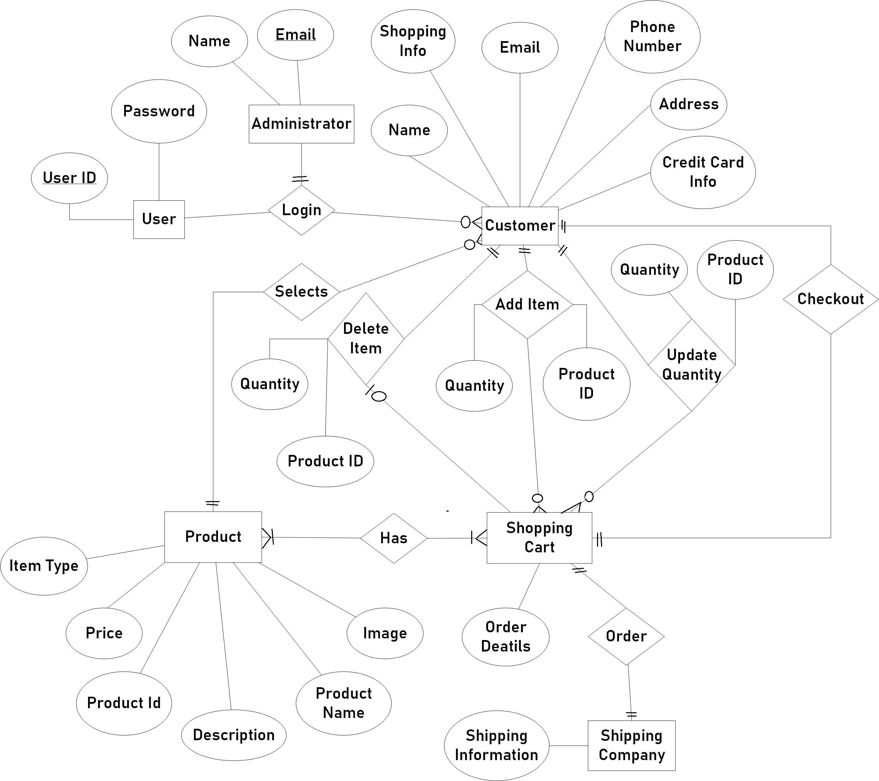

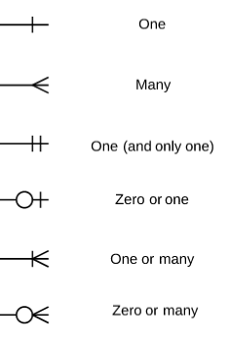

Notations

### **ACTIVITY DIAGRAMS OF E-COMMERCE SHOPPING WEBSITE MANAGEMENT SYSTEM**:

Login Activity:

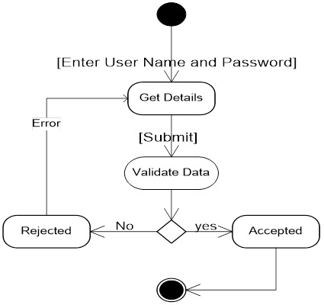

Registration Activity Diagram:

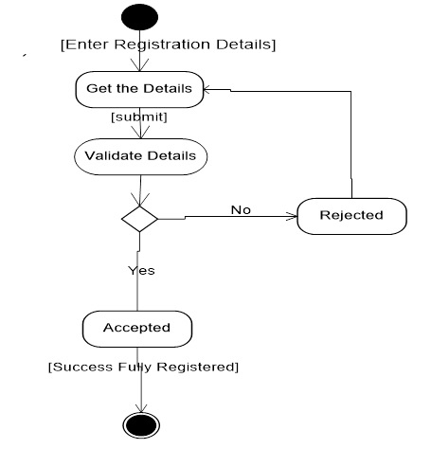

Admin Activity Diagram:

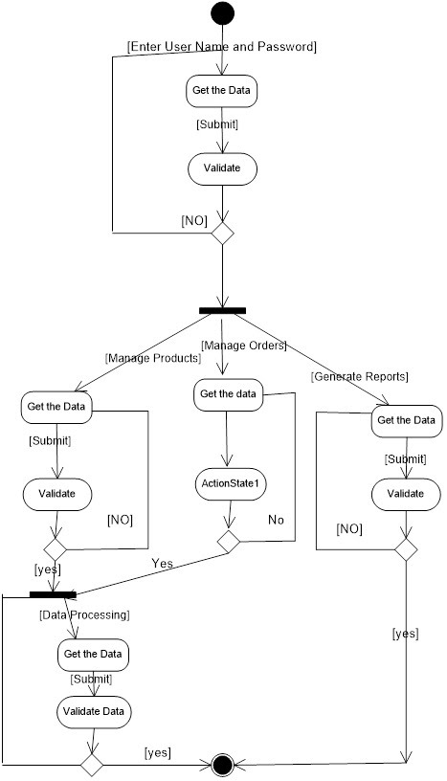

User Activity Diagram:

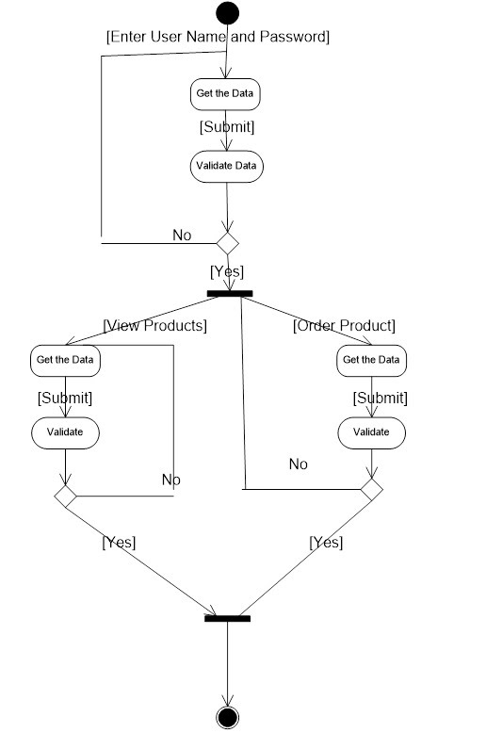

**DATA FLOW DIAGRAM (DFD)**

The DFD takes an input-process-output view of a system i.e., data objects flow into the software, are transformed by processing elements, and resultant data objects flow out of the software.

Data objects represented by labelled arrows and transformation are represented by circles also called as bubbles. DFD is presented in a hierarchical fashion i.e., the first data flow model represents the system as a whole. Subsequent DFD refine the context diagram (level 0 DFD), providing increasing details with each subsequent level.

The DFD enables the software engineer to develop models of the information domain & functional domain at the same time. As the DFD is refined into greater levels of details, the analyst performs an implicit functional decomposition of the system. At the same time, the DFD refinement results in a corresponding refinement of the data as it moves through the process that embody the applications.

A context-level DFD for the system the primary external entities produce information for use by the system and consume information generated by the system. The labelled arrow represents data objects or object hierarchy.

RULES FOR DFD:

· Fix the scope of the system by means of context diagrams.

· Organize the DFD so that the main sequence of the actions

· Reads left to right and top to bottom.

· Identify all inputs and outputs.

· Identify and label each process internal to the system with Rounded circles.

· A process is required for all the data transformation and Transfers. Therefore, never connect a data store to a data Source or the destinations or another data store with just a Data flow arrow.

· Do not indicate hardware and ignore control information.

· Make sure the names of the processes accurately convey everything the process is done.

· There must not be unnamed process.

· Indicate external sources and destinations of the data, with Squares.

· Number each occurrence of repeated external entities.

· Identify all data flows for each process step, except simple Record retrievals.

· Label data flow on each arrow.

· Use details flow on each arrow.

· Use the details flow arrow to indicate data movements.

### DATA FLOW DIAGRAM OF E-COMMERCE SHOPPING WEBSITE MANAGEMENT SYSTEM:

* 1. Login DFD:

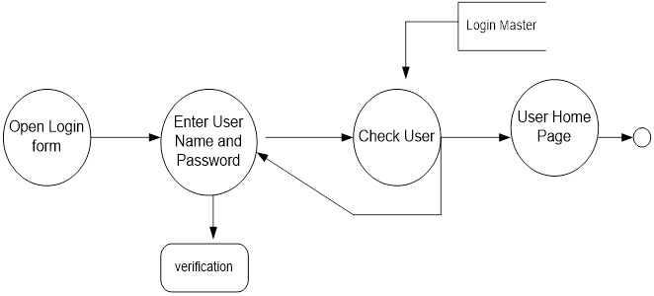

* 1. Admin Details Data Flow:

2nd Level DFD Diagram:

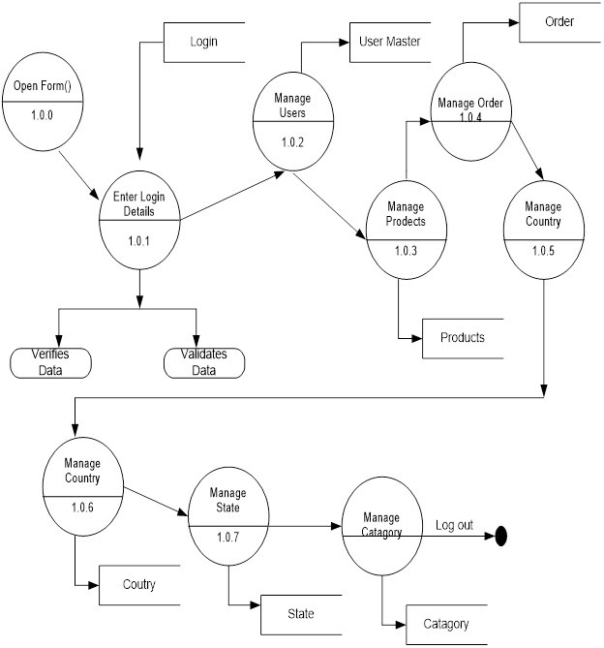

* 1. 2nd Level DFD for Manage Product:

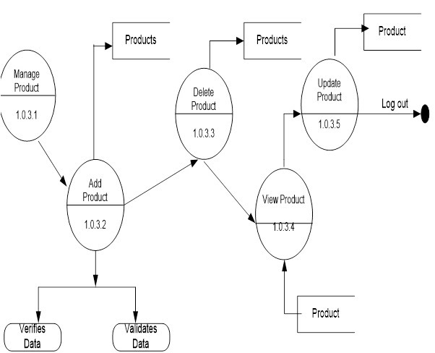

* 1. 2nd Level Product for Manage Order:

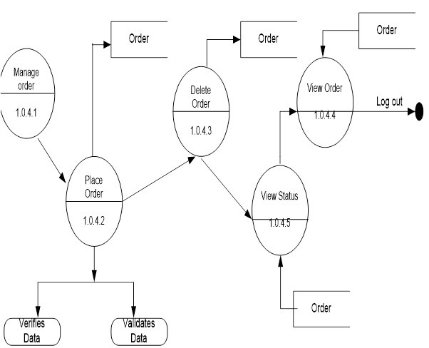

* 1. 2nd level DFD for User Activities:

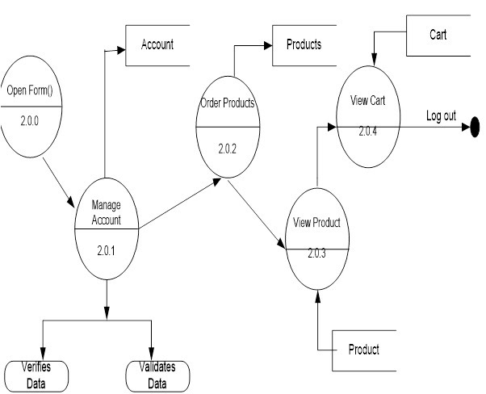

* 1. 2nd level DFD for New Registration:

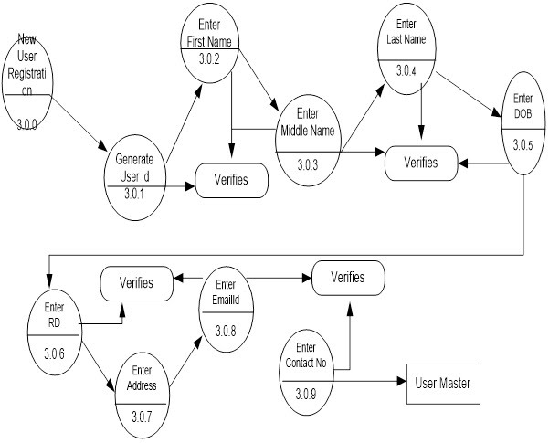

PROJECT MODULES

**MODULES**

This project contains 3 modules, those are

* ADMIN
* PRODUCTS
* USER

**MODULE DESCRIPTION**

**Admin:** When admin login, he saw the customer’s database, means how many users are authenticated to this website and how many users are transacting every day, and newly items are inserting into products.

**Products:** This module contains product name, and related image, and cost of its products. Like mobile phone, laptop, televisions, etc. Whatever customer wants.

**User:**  User entered into with his username and password, when he entered into this, he saw what items are available today, this product is available in this site. Chosen different items from website get those through door delivery.

IMPLEMENTATION

Implementation is the stage where the theoretical design is turned into a working system. The most crucial stage in achieving a new successful system and in giving confidence on the new system for the users that it will work efficiently and effectively.

The system can be implemented only after thorough testing is done and if it is found to work according to the specification.

It involves careful planning, investigation of the current system and its constraints on implementation, design of methods to achieve the changeover and an evaluation of change over methods a part from planning. Two major tasks of preparing the implementation are education and training of the users and testing of the system.

The more complex the system being implemented, the more involved will be the systems analysis and design effort required just for implementation.

The implementation phase comprises of several activities. The required hardware and software acquisition is carried out. The system may require some software to be developed. For this, programs are written and tested. The user then changes over to his new fully tested system and the old system is discontinued.

**CONCEPTUAL TECHNIQUE**

The information system development cycle for a website consists of three major stages.

1. Definition.

2. Design

3. Development.

4. Installation and operation.

The first stage of the process, which defines the information requirements for a feasible cost-effective system. The requirements are then translated into a physical system of forms, procedures, programs etc., by the system design, computer programming and procedure development. The resulting system is test and put into operation. No system is perfect so there is always a need for maintenance changes. To complete the procedure, there should be a post audit of the system to evaluate how well it performs and how well it meets the cost and performance specifications. The stages of definition, development and operation can therefore be divided into smaller steps or phrases as follows.

**Definition**

Proposed definition: preparation of request for proposed website.

Feasibility assessment: evaluation of feasibility and cost benefit of proposed website.

Information requirement analysis: determination of information needed.

**Design**

Conceptual design: User-oriented design of website development.

Physical system design: Detailed design of flows and processes in website processing system and preparation of program specification.

**Development**

Program development: coding and testing of computer programs.

Procedure development: design of procedures and preparation of user instructions.

**Installation and operation**

Conversion: final system test and conversion.

Operation and maintenance: Month to month operation and maintenance

Post audit: Evaluation of development process, website system and results are used at the completion of each phase, formal approval sign-off is required from the users as well as from the manager of the project development.

**TESTING**

Testing is a process of executing a program with the intent of finding an error. Testing is a crucial element of software quality assurance and presents ultimate review of specification, design and coding.

System Testing is an important phase. Testing represents an interesting anomaly for the software. Thus, a series of testing are performed for the proposed system before the system is ready for user acceptance testing.

A good test case is one that has a high probability of finding an as undiscovered error. A successful test is one that uncovers an as undiscovered error.

**Testing Objectives**:

1. Testing is a process of executing a program with the intent of finding an error.

2. A good test case is one that has a probability of finding an as yet undiscovered error.

3. A successful test is one that uncovers an undiscovered error

Testing Principles:

* All tests should be traceable to end user requirements.
* Tests should be planned long before testing begins.
* Testing should begin on a small scale and progress towards testing in large.
* Exhaustive testing is not possible.
* To be most effective testing should be conducted by an independent third party.

**Testing Strategies**:

A strategy for software testing must accommodate low-level tests that are necessary to verify that all small source code segment has been correctly implemented as well as high-level tests that validate major system functions against customer requirements.

**Testing Fundamentals**:

Testing is a process of executing program with the intent of finding error. A good test case is one that has high probability of finding an undiscovered error. If testing is conducted successfully, it uncovers the errors in the software. Testing cannot show the absence of defects, it can only show that software defects present.

**Testing Information flow**:

Information flow for testing flows the pattern. Two class of input provided to test the process. The software configuration includes a software requirements specification, a design specification and source code.

Test configuration includes test plan and test cases and test tools. Tests are conducted and all the results are evaluated. That is test results are compared with expected results. When erroneous data are uncovered, an error is implied and debugging commences.

**UNIT TESTING**:

Unit testing is essential for the verification of the code produced during the coding phase and hence the goal is to test the internal logic of the modules. Using the detailed design description as a guide, important paths are tested to uncover errors with in the boundary of the modules. These tests were carried out during the programming stage itself.

* In admin module while testing we found that in the admin login form users were able to join by giving wrong passwords also and the system was not hiding the password in the password field and after some adjustments in the coding, we found the solution.
* There was no problem in product module.
* In user module while testing we found problems in the billing system in the cart feature. We found that billing system was not working, it was not adding the prices and showing the total value but now its working after doing some changes in the coding.

**INTEGRATION TESTING**:

Integration testing focuses on unit tested modules and build the program structure that is dictated by the design phase.

We did this testing in 2 steps:

1st we integrated the product module with the admin module there we were successful. It was bug free.

2nd we integrated the user module to with the previous integrated model and we found that a bug has occurred. We saw that when a user is searching for a single type of product it is actually not working that way. It was showing all the types of product and every product we have. After doing some adjustments in the designing and the coding phase now its bug free.

**SYSTEM TESTING**:

System testing tests the integration of each module in the system. It also tests to find discrepancies between the system and its original objective, current specification and system documentation. The primary concern is the compatibility of individual modules. Entire system is working properly or not will be tested here, and specified path ODBC connection will correct or not, and giving output or not are tested here these verifications and validations are done by giving input values to the system and by comparing with expected output. Top-down testing implementing here.

* After integrating all the modules and when it became bug free as stated earlier, we found no problem in the system testing.

OUTPUT SCREENS

CODE SNIPPETS

CONCLUSION

This website provides a computerized version of online shopping management system which will benefit the customer as well as the admin of system. It makes entire process online where customer can search products, admin can accept the order and do billing system. It also has a facility for user login where user can login and can save the product of their choice which they want to buy later. It has a facility of admin login where admin can add its reply to the queries of the customer through message system and can maintain the management of the system.

FUTURE ENHANCEMENTS

This application avoids the manual work and the problems concern with it. It is an easy way to obtain the information regarding the various products information that are present in the Super markets.

Well, I and my team members have worked hard in order to present an improved website better than the existing one’s regarding the information about the various activities. Still, we found out that the project can be done in a better way. Primarily, when we request information about a particular product it just shows the company, product id, product name and no. of quantities available. So, after getting the information we can get access to the product company website just by a click on the product name.

The next enhancement that we can add the searching option. We can directly search to the particular product company from this site. These are the two enhancements that we could think of at present.

BIBLIOGRAPHY

The following books and websites were referred during the analysis and execution phase of the project:

**BOOKS**

* **Korth**: Database System Concept
* **Navathe**: Fundamentals of Database System
* **Deshpande**: SQL and PL/SQL for Oracle 11g
* **Robin Nixon**:Learning PHP, MySQL, JavaScript, & CSS: A Step-by-Step Guide to Creating Dynamic Websites

**WEBSITES**

* <https://www.google.com/>
* <https://www.bitkart.com/>
* <https://www.flipkart.com/>